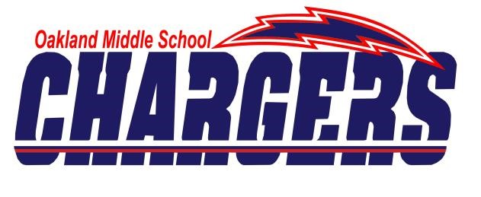
2017-2018
Oakland Chargers Basketball

Date | Opponent | Time | Result
Sat., Nov. 4  Rutherford County Jamboree @ OMS | Blackman | TBA
Thurs., Nov. 9 | Mt. Juliet | 5:00 – Varsity Only
Sat., Nov. 11 | @ E.O. Coffman | 2:00/4:00
Mon., Nov. 13 | @ Stewarts Creek* | 4:00/6:00
Thurs., Nov. 16 | Rock Springs* | 4:00/6:00
Mon., Nov. 20 | @ Buchanan* | 4:00/6:00
Thurs., Nov. 30 | Christiana* | 4:00/6:00
Mon., Dec. 4 | Rockvale* | 4:00/6:00
Thurs., Dec. 7 | @ Central Magnet* | 4:00/6:00
Mon., Dec. 11 | @ Siegel* | 4:00/6:00
Thurs, Dec. 14  Charger Invitational  @ OMS | TBD | TBD
Fri, Dec. 15  Charger Invitational  @ OMS | TBD | TBD
Sat, Dec. 16  Charger Invitational  @ OMS | TBD | TBD
Mon, Dec. 17  Charger Invitational  @ OMS | TBD | TBD
Thurs., Jan. 4 | @ Rocky Fork* | 4:00/6:00
Mon., Jan. 8 | @ Smyrna* | 4:00/6:00
Thurs., Jan. 11 | @ Lavergne* | 4:00/6:00
Mon., Jan. 16 | @ Mt. Juliet | 5:00 – Varsity Only
Thurs., Jan. 18 | Blackman* | 4:00/6:00
Jan 21 – Jan 26  Conf. Tournament | @ Smyrna Middle | TBD
Jan. 29  Sub-State Game | TBD | TBD
Jan. 31 – Feb. 5  State Tournament | TBD | TBD

*Denotes conference games.
Varsity Games = Girls begin at 6:00; Boys immediately after unless stated otherwise.
JV Games = Girls begin at 4:00; Boys immediately after unless stated otherwise.

